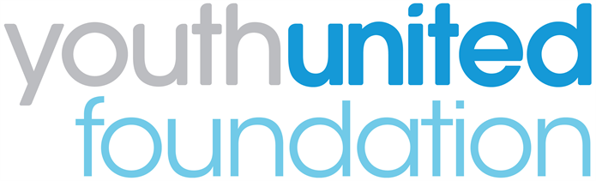

Youth United Panel: Application Form

We are looking for applications from 16-24 year olds who are currently members of any of the following uniformed youth groups: Air Cadets; Army Cadet Force; The Boys' Brigade; Fire Cadets; The Girls' Brigade England & Wales; Girlguiding; Jewish Lads' and Girls' Brigade; The Scout Association; Sea Cadets; St John Ambulance; Volunteer Police Cadets.
Section 1: your details

Name:
Date of birth:

Home address:
Postcode:
Email:
Landline:
Mobile:

Uniformed youth group:

Named group leader who will support your application:

If you are under 18 years old, please ask your parent/guardian/carer to provide the following details too. We will require written permission from them.

Name of parent/guardian/carer:
Home address:
Postcode:
Email:
Landline:
Mobile:

Section 2: more about you

- Why do you want to join the Youth United Panel? What do you want to gain from being a member?

- Why do you think you should be selected for the Panel? What do you feel you could bring to the role?
For example, you might have specific skills, knowledge or life experiences that you’d like us to know about.

- Please tell us about yourself. Use up to 200 words to sum up your personality, hobbies and interests or strengths. (Please stay within the word limit.)

- If you could design and deliver a project of your choosing during your time on the Youth Panel, what would you choose to do and why? Dream Big! There is no right or wrong answer, we’re just interested to hear your ideas…

Section 3: your availability

We will be holding the first Panel event on X date on Zoom.

Are you available to attend? Yes [ ] No [ ]

Will you need to have a chaperone? Yes [ ] No [ ]

Section 5: diversity monitoring information

Youth United Foundation are committed to promoting equality and diversity. We invite you to complete this section of the application form so that we can monitor and analyse information about the diversity of the people who submit an application. Any information you provide will be treated as strictly confidential. It will not be shared or used by anyone directly involved in the selection process. We will transfer all the information provided into a database and then destroy all individual forms. No information will be published or used in any way that allows any individual to be identified. You are not obliged to answer the questions on this form. If you do not wish to answer a question simply answer ‘Prefer not to say’.

- Your gender (please put an tick in the appropriate box)

Male Female Third gender/other

Prefer not to say

- Your sexual orientation (please put an X in the appropriate box)

Bisexual Gay man Gay woman/lesbian

Heterosexual Other Prefer not to say

- Your religion or belief (please put an X in the appropriate box)

None Buddhist Christian

Hindu Jewish Muslim

Sikh Any other Prefer not to say

- Your ethnic origin (please put an X in the appropriate box)

White

British English Welsh Scottish

Northern Irish Gypsy or Irish Traveller Other

Mixed/multiple ethnic background

White and Black Caribbean White and Black African

White and Asian Any other/ multiple ethnic background

Asian/Asian British

Bangladeshi Chinese Indian Pakistani

Any other Asian background

Black/African/Caribbean/Black British

African Caribbean

Other Black/African/ Caribbean background

Other ethnic group

Arab Any other ethnic group Prefer not to say

- Do you consider that you have a disability?

Yes No Prefer not to say

Section 6: when will I hear back?

Please email your completed application form by email to gbco@gb-ministries.org or via post to the GB Support Centre by Monday, 20 December.

Applicants will be informed if they have an interview as soon as possible. Interviews with shortlisted candidates will take place by Zoom during week commencing 10th January. We will be as flexible as possible with interview times.

If you have any other questions, please email sarah.atkins@yuf.org.uk

Section 7: How will you protect my privacy?

Your privacy is really important to us. By filling in the Youth United Panel application form, you are consenting to Youth United Foundation using your personal information to keep in touch with you over the course of the project. If your application is not successful, or you decide to withdraw your application, we will delete your personal data from our files.

If you want to withdraw your consent at any time you can contact youth.united@yuf.org.uk if you would like to see our full Privacy Notice you can do so here

We look forward to receiving your application!

