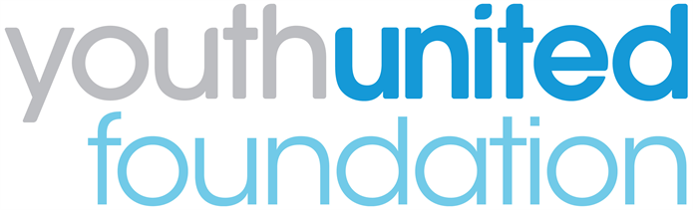

Youth United Panel 2022: Application Guide

Please read these notes carefully before filling in your application.

1. What is the Youth United Panel?
The Youth United Panel aims to give young people aged 16-24 a voice on the future of uniformed youth services. The Panel enables young people with experience of uniformed groups to work together with those from other groups and provide their views to decision-makers at the national level.

2. Who can join?
We are seeking to recruit 11 individuals (one representative from each organisation) to become Youth United Panel members from January 2022 to January 2023. These Panel members can live anywhere in England.

We are looking for applications from 16-24 year olds who are currently members of, or volunteers/young leaders with uniformed youth groups including Air Cadets; Army Cadet Force; The Boys' Brigade; Fire Cadets; The Girls' Brigade England & Wales; Girlguiding; Jewish Lads' and Girls' Brigade; The Scout Association; Sea Cadets; St John Ambulance and Volunteer Police Cadets.

We are seeking young people who can be ‘experts through their experience’ of uniformed youth services.

We are looking for people who are team players and willing to get involved with all the Youth Panel activities. We are also very keen to make sure that the Youth Panel engages a diverse range of young people from different backgrounds and geographical areas.

3. If I join, what will I have to do?

- Take part in meetings to discuss topics relating to YUF work and that are important to you
- Social activism: create stories that can be shared on our website and social media
- Help to develop the YUF strategy and influence the way we work
- Represent the Youth Panel at events, meetings, and functions such as Back Youth Alliance meetings, political party conferences and the UN Conference of youth
- Produce blogs on tasks undertaken as part of the Youth Panel, to be shared on the YUF website and social media pages
- Interview Senior Leaders about their plans for the future of young people and how they are involving young people in decision making.
- Highlight the fantastic things that young people are doing in your organisation

4. What will I get from being part of the Panel?

As a Panel member, you will have the opportunity to:

- Discuss issues with decision-makers: You will meet key officials from government and other agencies and help them to understand what young adults in your peer group think about uniformed youth services.
- Develop your skills and experience: You will gain valuable skills and experience, which you will be able to use for your CV and applications to further or higher education or employment.
- Represent the views of other young people: You will give a voice to young people in your area by helping them to get their views heard.
- Meet new people: You will meet a diverse range of young people from across England, and work alongside professionals from different organisations.

Travel expenses will be covered for attendance at all meetings and lunch will be provided.

5. How do I apply?

Please fill in the enclosed application form and email it to gbco@gb-ministries.org or by post to the GB Support Centre by Monday, 20 December.

- Section 1: If you are under 18, you must also fill out the section regarding your Parent /Guardian /Carer. All members under the age of 18 will be asked to bring along a signed consent form to the first event.

- Privacy: Your privacy is really important to us. By filling in the Youth United Foundation Panel application form, you are consenting to Youth United Foundation using your personal information to keep in touch with you over the course of the project. If your application is not successful, or you decide to withdraw your application, we will delete your personal data from our files. If you want to withdraw your consent at any time you can contact the Data Protection officer at youth.united@yuf.org.uk and if you would like to see our full Privacy Notice you can do so here

6. What happens next?

Please email your completed application form to gbco@gb-ministries.org or by post to the GB Support Centre by Monday, 20 December.

After the deadline, we will carry out interviews via Zoom with shortlisted applicants. All applicants will be informed if they have an interview or not. Interviews will take place the week commencing 10th January 2022.

We look forward to receiving to receiving your application!

